Appendix

Use cases

Contents

Product Boundary Use Case Diagram 2

Product Use Case List 3

Use Cases: 4

Happy scenario 4

Wrong Scenario 4

No funds scenario 5

Product Boundary Use Case Diagram.

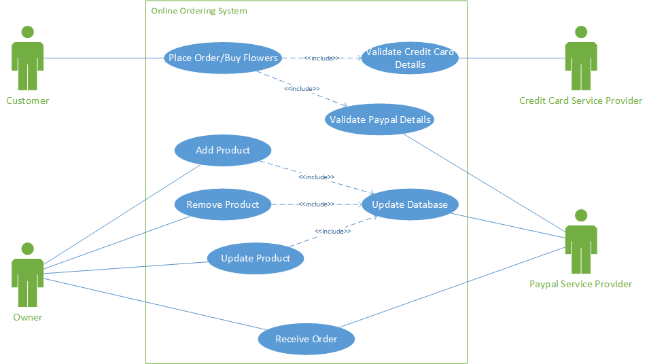

# Product Use Case List

* Receive Order: The staff owner receives an email and fax after the buyer pays for item.
* Update Product: To update products on the website.
* Remove product: To remove a product from the website.
* Add product: To add products on the website.
* Place Order/buy flowers: Customer wants to buy products online
* Validate credit card Details: Credit Card provider validates credit details.
* Validate PayPal Details: PayPal validates PayPal/credit information.
* Update Database: Update database with information provided.

# Use Cases:

## Happy scenario

* The customer goes on to the website.
* Picks an item which then is purchased via the PayPal system.
* Enters details such as credit card and the address of the recipient the product will be to send to.
* PayPal processes the order.
* Emails are sent to customer and staff
* Falco sends a fax to the staff in the shop.
* The staff make up customers order which is then Delivered to the
* customer, smiles all round.

## Wrong Scenario

* + The customer visits the website.
  + Picks an item which is bought using PayPal.
  + Enters details such as credit card and address details to send to.
  + Wrong details entered, asked to try again.

## No funds scenario

* The customer goes on to the website.
* Picks an item Is brought to PayPal.
* Enters details such as credit card and address to send to.
* No money in credit card or PayPal credit.
* Asked to enter other details.

|  |  |  |  |
| --- | --- | --- | --- |
| USE CASE NAME: | Buy flowers | | |
| USE CASE ID: | UC3 | | |
| PRIORITY: | Normal | | |
| SOURCE: | Owner | | |
| PRIMARY BUSINESS ACTOR: | Online customer | | |
| OTHER PARTICIPATING ACTORS: | PayPal | | |
| OTHER INTERESTED STAKEHOLDERS: | Staff | | |
| DESCRIPTION: | Customer wants to buy products online | | |
| PRE-CONDITION: | Has to have credit card/PayPal account | | |
| TRIGGER: | Need to buy flowers | | |
| TYPICAL COURSE OF EVENTS: | **Actor Action** | **System Response** | |
| Step 1: | Customer browse business **website** | System displays **home page** | |
| Step2: | Customer selects Add to Cart | System will display selected item and payment options | |
| Step 3: | Customer select PayPal payment | System display PayPal Login dialogue box | |
| Step 4: | Customer Login | System display payment details and confirmation button | |
| Step 5: | Customer confirms order | System displays confirmation details back | |
| **Step 6:** | Customer press confirm | System displays successful order | |
| **Sub Flows** | **Actor Action** | **System Response** | |
| at Step 2 | Customer wants to add more items | System displays Home page | |
|  | Customer adds another item | System will display selected item and payment options | |
| **ALTERNATE COURSES:** | **Actor Action** | | **System Response** |
| at Step 3 | customer selects credit card payment options | | System display credit card validation form |
|  | Customer enters credit card | | System display payment details and confirmation button |
|  | customer confirms order | | System displays home page |
| at Step 2 | Customer cancels the order | | System displays order details remove and continue to home page |
| CONCLUSION: |  | | |
| POSTCONDITION: | Email is sent to the business and customer | | |
| BUSINESS RULES | The customer has to have a credit card/PayPal | | |
| IMPLEMENTATION CONSTRAINTS AND SPECIFICATIONS | Customer has to have internet connection | | |
| ASSUMPTIONS: | None | | |
| OPEN ISSUES: | PayPal/credit card fail | | |
| Special Requirements | None | | |
| Additional Information | none | | |

|  |  |  |  |
| --- | --- | --- | --- |
| **USE CASE NAME:** | | Add new Products on Website | |
| **USE CASE ID:** | | UC1 | |
| **PRIORITY:** | | N/A | |
| **PRIMARY BUSINESS ACTOR:** | | Owner | |
| **OTHER PARTICIPATING ACTORS:** | | Staff | |
| **OTHER INTERESTED STAKEHOLDERS:** | | Online customers | |
| **DESCRIPTION:** | | To add products on the website. | |
| **PRE-CONDITION:** | | Has to be logged in, Has internet connection. | |
| **TRIGGER:** | | Has a new product to update on website | |
| **TYPICAL COURSE OF EVENTS:** | **Actor Action** | | **System Response** |
| **Step 1**: | User logs in | | System displays admin screen with additional options such as view traffic |
| **Step2**: | User clicks addnew product button | | System displays form to be filled out with criteria to add a new product (title, price, PayPal link and photo). |
| **Step 3**: | User fills information | | System takes input |
| **Step 4**: | User clicks save. | | System saves information to database. |
| **Sub Flows** | **Actor Action** | | **System Response** |
| PayPal extend step 2 | Logs into PayPal | | Displays PayPal options home screen |
|  | User clicks add new product | | System displays form to be filled out with criteria to add a new product (such price and details) |
|  | User click Saves | | Systems saves and refreshes to the home screen. |
|  | User Now has access to the PayPal link | |  |
| **ALTERNATE COURSES:** | **Actor Action** | | **System Response** |
| At Step 3 inputting information | User clicks submit with missing criteria | | System refreshes page displaying input missing |
| At Step 4 , Adding duplicate Products | User tries to input duplicate item | | System refreshes page displaying message about duplicate item. |
| At all steps , System failure | System crashes while user is trying to update | | System tries to save information locally for when it goes back online. |
| **CONCLUSION:** | None | | |
| **POSTCONDITION:** | None | | |
| **BUSINESS RULES** | None | | |
| **IMPLEMENTATION CONSTRAINTS AND SPECIFICATIONS** | None | | |
| **ASSUMPTIONS:** | None | | |
| **OPEN ISSUES:** | Database Errors | | |
| Special Requirements | Must have a new product to add to website. Must also have changes to website. | | |
| Additional Information | Need to be verify which information should displayed or should not be displayed | | |

|  |  |  |  |
| --- | --- | --- | --- |
| **USE CASE NAME:** | Update Products on Website | | |
| **USE CASE ID:** | 1 | | |
| **PRIORITY:** | N/A | | |
| **PRIMARY BUSINESS ACTOR:** | Owner | | |
| **OTHER PARTICIPATING ACTORS:** | Staff | | |
| **OTHER INTERESTED STAKEHOLDERS:** | Buyers | | |
| **DESCRIPTION:** | To update products on the website. | | |
| **PRE-CONDITION:** | Has to be logged in, Has internet connection. | | |
| **TRIGGER:** | Has a product they wish to update on website. | | |
| **TYPICAL COURSE OF EVENTS:** | **Actor Action** | **System Response** | |
| **Step 1**: | User logs in | System displays admin screen with additional options such as view traffic | |
| **Step2**: | User clicks update product button | System displays form to be filled out with criteria to update a product (title, price, PayPal link and photo). | |
| **Step 3**: | User enters Product Id Number | System refreshes and fill form with product information from database where id matches | |
| **Step 4**: | User Makes changes | System makes changes | |
| **Step 5** | User clicks save. | System saves information to database and updates projects. | |
| **Sub Flows** | **Actor Action** | | **System Response** |
| PayPal extend step 4 | Logs into PayPal | | Displays PayPal options home screen |
|  | User clicks add update product input id of product | | System displays form to be filled out with criteria to update product (such price and details). |
|  | User inputs updated information | | System feedback |
|  | User click Saves | | Systems saves and refreshes to the home screen. |
|  | User has now updated the product | |  |

|  |  |  |  |
| --- | --- | --- | --- |
| **ALTERNATE COURSES:** | | **Actor Action** | **System Response** |
|  | | None | None |
| **CONCLUSION:** | None | | |
| **POSTCONDITION:** | None | | |
| **BUSINESS RULES** | None | | |
| **IMPLEMENTATION CONSTRAINTS AND SPECIFICATIONS** | None | | |
| **ASSUMPTIONS:** | None | | |
| **OPEN ISSUES:** | Database Errors | | |
| Special Requirements | Must have a product they wish to update on website. | | |
| Additional Information | Need to be verify which information should displayed or should not be displayed | | |

|  |  |  |  |  |  |
| --- | --- | --- | --- | --- | --- |
| **USE CASE NAME:** | Remove Products on Website | | | | |
| **USE CASE ID:** | 1 | | | | |
| **PRIORITY:** | N/A | | | | |
| **PRIMARY BUSINESS ACTOR:** | Owner | | | | |
| **OTHER PARTICIPATING ACTORS:** | Staff | | | | |
| **OTHER INTERESTED STAKEHOLDERS:** | Buyers | | | | |
| **DESCRIPTION:** | To remove a product from the website. | | | | |
| **PRE-CONDITION:** | Has to be logged in, Has internet connection. | | | | |
| **TRIGGER:** | Has a product they wish to remove from website. | | | | |
| **TYPICAL COURSE OF EVENTS:** | **Actor Action** | **System Response** | | | |
| **Step 1**: | User logs in | System displays admin screen with additional options such as view traffic | | | |
| **Step2**: | User clicks remove product button | System displays form to be filled out product Id | | | |
| **Step 3**: | User enters Product Id Number | System refreshes and asks if they wish to remove this product. | | | |
| **Step 4**: | User inputs choose | System makes changes | | | |
| **Step 5** | User clicks save. | System saves information to database and removes projects. | | | |
| **Sub Flows** | **Actor Action** | | | **System Response** |
| PayPal extend step 5 | Logs into PayPal | | | Displays PayPal options home screen |
|  | User clicks remove product button and inputs id of product | | | System displays form of the product information from the user wishes to remove. |
| Step5 | User click remove | | | Systems removes product and refreshes to the home screen. |
|  | User has now removed the product | | |  |
| **ALTERNATE COURSES:** | **Actor Action** | | **System Response** | |
| At step5: remove product option | User clicks cancel | | System refresh to the home screen | |
| At step4: remove product option | User clicks cancel | | System refresh to the home screen | |
| **CONCLUSION:** | None | | | | |
| **POSTCONDITION:** | None | | | | |
| **BUSINESS RULES** | None | | | | |
| **IMPLEMENTATION CONSTRAINTS AND SPECIFICATIONS** | None | | | | |
| **ASSUMPTIONS:** | None | | | | |
| **OPEN ISSUES:** | Database Errors | | | | |
| Special Requirements | Must have a product they wish to update on website. | | | | |
| Additional Information | Need to be verify which information should displayed or should not be displayed | | | | |

|  |  |  |  |  |  |
| --- | --- | --- | --- | --- | --- |
| **USE CASE NAME:** | Receive Orders | | | | |
| **USE CASE ID:** | UC 2 | | | | |
| **PRIORITY:** | High | | | | |
| **SOURCE:** | Client | | | | |
| **PRIMARY BUSINESS ACTOR:** | Owner | | | | |
| **OTHER PARTICIPATING ACTORS:** | Staff involved in the delivery  System holding email account  FaxCo | | | | |
| **OTHER INTERESTED STAKEHOLDERS:** | People buying the flowers | | | | |
| **DESCRIPTION:** | The staff, owner wants to check the email received after the buyer pays for item. | | | | |
| **PRE-CONDITION:** | The user must hold email account | | | | |
| **TRIGGER:** | Payment received | | | | |
| **TYPICAL COURSE OF EVENTS:** | | **Actor Action** | **System Response** | |
| **Step 1**: | | User browse to email account | System displays log in box | |
| **Step2**: | | User logs in | System displays list of emails | |
| **Step 3**: | | User logs out | System closes email list | |
| **ALTERNATE COURSES:** | | **Actor Action** | | **System Response** | |
| At step 2: | | user provides incorrect login details | | System prompts to re enter the details | |
| POSTCONDITION: | | None | | |
| BUSINESS RULES | | None | | |
| ASSUMPTIONS: | | None | | |
| OPEN ISSUES: | | Connection to email account may fail | | |

Task 2

Post Primary Requirements

* To be able to update, remove and add product within 2 to 4 clicks away from the home screen.
* The sample should be straightforward and easy to use.
* Must ask for id, name, and description, upload a photo and PayPal links.
* Able to view information before changing products.

Home Screen

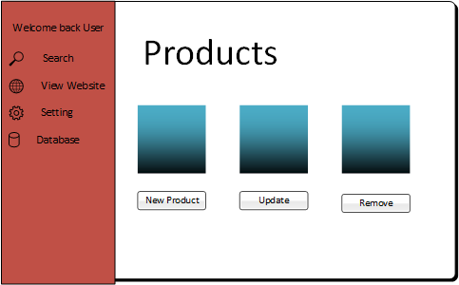

Add Product

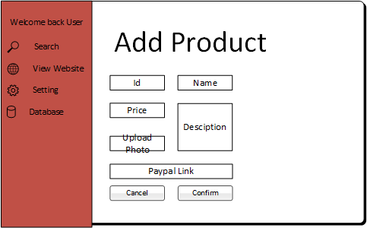

Remove Product

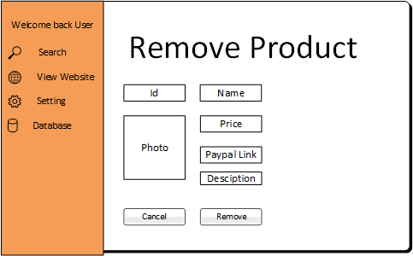

Update Product

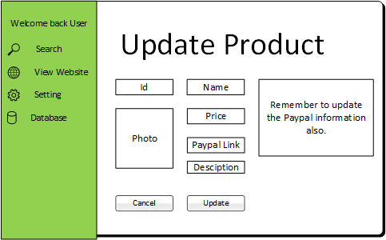

Final Requirements (Same as above)

* To be able to update, remove and add product within 2/4 clicks away from the home screen.
* The sample should be straightforward and easy to use.
* Must ask for id, name, and description, upload a photo and PayPal links.
* Able to view information before changing products.